Project Report : “Tripartite Baltic” SIA



Company overview and analysis:
The company is officially registered in Register of Enterprises of Latvia on April 25 2007 as a limited liability company with the stock capital of 2000 LVL (~2850 EUR). Its main field of activities according to the official information of Latvia’s Central Statistics Bureau is “another unclassified commercial services”; according to experts’ explanations – ship maintenance and supplies; according to the information on company’s website (www.tripartite.lv), “the main task for the company is to provide support for the Baltic Navy in order to assure operational readiness of the ships. (..) Company can provide maintenance in condition, overhaul, modernization and spare parts supply”.
The director and head of the board of the company is Michael Robert Edgar Rapeti-Trastour (home address – France, Saint Evarzec, Chateau de Kerinou), member of the board – Andrejs Zvaigzne (born 18.06.1963, address – Riga, Vilandes str. 12-9).
The company has three main shareholders: Michael Robert Edgar Rapeti-Trastour (30%), Andrejs Zvaigzne (20%), Tripartite Propulsion (50%; official address - 6, rue Jean Baptiste Bousquet, 29000 Quimper, France; more than 10 years of experience in providing the logistic support for the vessels; part of the Tripartite Group, specialized in NATO supply and logistics for surface vessels, submarines and mainly Tripartite mine hunters).
The company is just starting its activities in Latvia, and up to now there it has only one known contract with Latvian navy; however its member of board Andrejs Zvaigzne until recently has served in National Armed forces of Latvia (commander senior grade, pensioned off due to health reasons officially in October 2007) and is reported to have good contacts in this field. It means that the company has fairly good chances in its business with state structures.
Risk Evaluation
Company name: Tripartite Baltic SIA |  | Annex number
Evaluation of the company  Professional standings: | A new company in Latvian market, founded less than a year ago. No public financial statements yet (must be received by the State Revenue Service until April, 2008). | [1]
Owners' standings: | Ship-building experts have some knowledge about “Tripartite Group” as a serious global player. | ???
Directors standings: | Andrejs Zvaigzne nominally known previously as a National Armed Forces officer. Personal debt (officially declared) – LVL 39 000 or 55 500 EUR, annual earnings – appr. LVL 20 000 or 28 500 EUR. | [6], [7]
Court case/ juridical proceedings: | No court cases | [1]
Bankruptcy record: | No bankruptcy records | [1]
Credit risk: | N/A | -
Other information: | N/A | -
REMARK:
-
Company visit report:
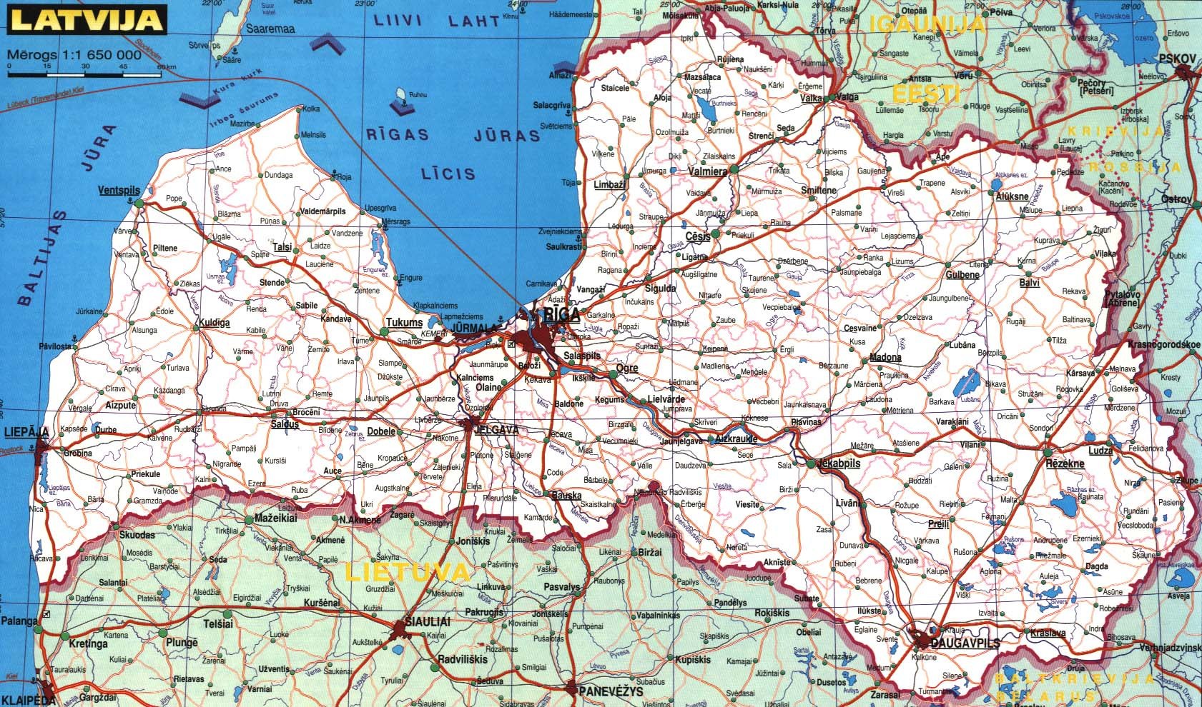 | 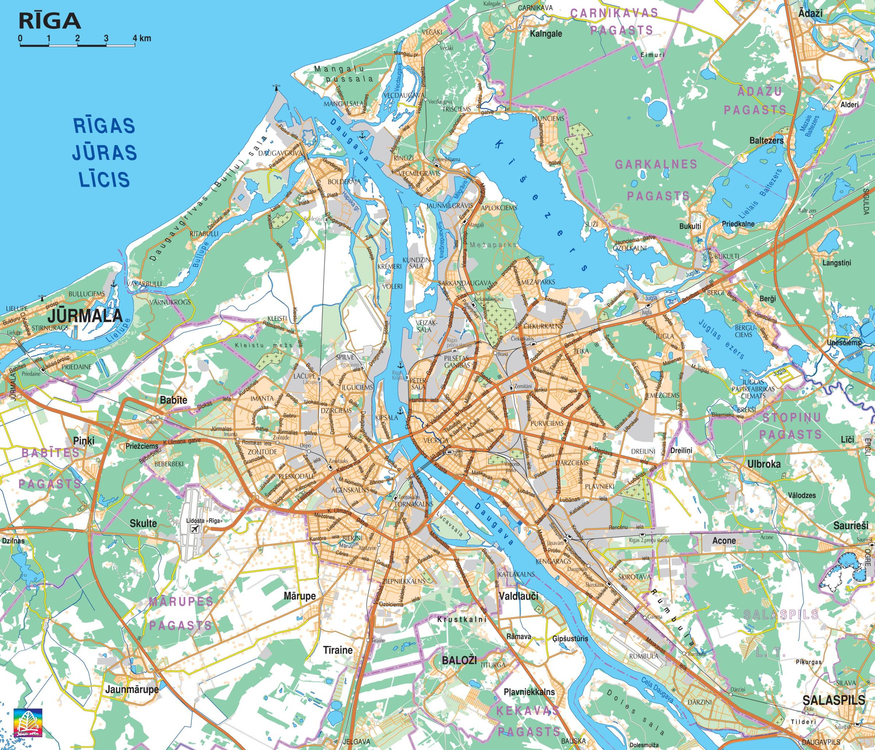 | 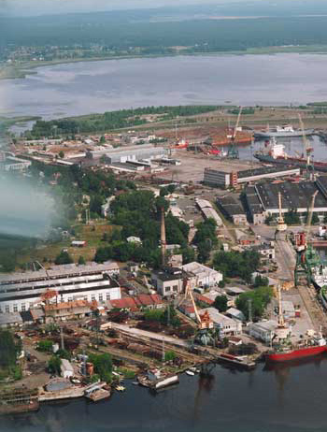
„Tripartite Baltic” SIA is situated in Riga – capital city of Latvia. | The official address of the company is in the „quiet centre” of Riga, the real – in Riga city port territory rather far from the centre. | The only „map of how to get into the company’s office” provided on company’s website.
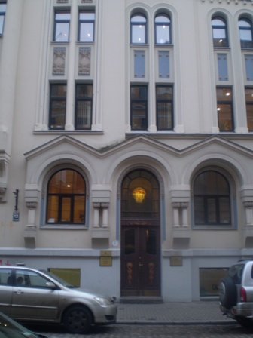 | 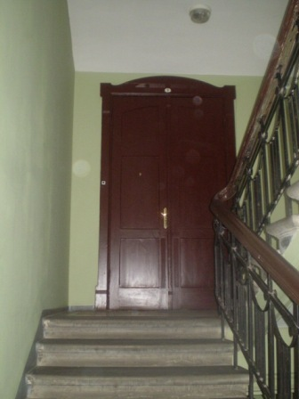 | 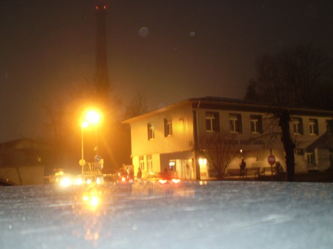
The official address of „Tripartite Baltic”: house in the „quiet centre” of Riga. | The official office of „Tripartite Baltic”; in reality – a flat. | The real address of the company mentioned on its website. The office cannot be found.

The official address of the company is in the so called “quiet centre” of Latvia’s capital Riga. The house Nr. 12 on Vīlandes street is the one in which lawyers’ office “Bļugers un Plaude”, representative offices of “Colgate-Palmolive” and “Nestle Baltics” a.o. offices are situated. The manager of the house has never heard of company “Tripartite”. Office Nr. 12 in fact is a flat presumably owned by Andrejs Zvaigzne. A woman was met in the flat, and the visitors were given Mr. Zvaigzne’s cellular phone number (+371 29478533).
Visit onsite 2 : the address of the company mentioned in company’s website is Gāles 2. This is a vast territory in Riga port. The same address is used by more than 20 companies. Office of “Tripartite Baltic” cannot be found.

Company organizational chart:
- Structure inside the company: no data
- Structure of the company: single company, part of “Tripartite Group” (daughter companies in France, Belgium, Netherlands, Turkey, Pakistan, Taiwan).
Company name: |  | Annex number
Registration date and number / company code: | Registration licence Nr. K045579, registration number 40003918093, registration date 25.04.2007 | [1]
Address where company was registered (first address of the company): | Rīga, Vilandes street 12-9, LV-1010 | [1]
Tax number/ VAT code: | 40003918093 | [1]
Staff number: | N/A | -
Current Address of the company (present address of the company): | Official: Riga, Vilandes street 12-9, LV-1010  Real : Riga, Gales street 2, LV-1015 | [1], [8]
Phone number: | +371 67080852 | [8]
Fax: | + 371 67349699 | [8]
Email: | info@tripartite.lv | [8]
Website: | www.tripartite.lv | [8]
Domain name: | Official owner: Tripatite Baltic, SIA  domain: tripartite.lv  descr: Tripatite Baltic, SIA  tech-c: 18379-LUMII  admin-c: 62506-LUMII  nserver: ns1.deac.lv  nserver: ns2.deac.lv  changed: dns-reg@nic.lv 20070612  source: LUMII  person:  address: none  phone: 00371 29478533  e-mail: andzv@hotmail.com  nic-hdl: 62506-LUMII  source: LUMII  person:  address: none  phone: +371 67842298  phone: +371 26312211  phone: +371 26594949  fax-no: +371 67506505  e-mail: hostmaster@deac.lv, elukss@deac.lv, hostmaster@deac.eu  nic-hdl: 18379-LUMII  source: LUMII | [9]
REMARK:  The official address of the company is the flat of its member of board and co-owner Jānis Zvaigzne. However the real office of the company is situated in Riga port, near the JSC Riga Shipyards (Rīgas kuģu būvētava). |  | [1], [8]
Stated capital: | LVL 2000 (appr. 2850 €) | ???
Owners, nationality and share: | Three main stockholders:  - Michael Robert Edgar Rapeti-Trastour (France, 30%),  - Andrejs Zvaigzne (Latvia, 20%),  - Tripartite Propulsion (France, 50%). | [1]
Owners' other investments: | Andrejs Zvaigzne: “A. Zvaigznes komercfirma” (founded 11.04.1992; 100%)  Michael Robert Edgar Rapeti-Trastour: no other investments in Latvia  Tripartite Propulsion: no other investments in Latvia | [2], [3], [4]
Directors: | Director and head of the board - Michael Robert Edgar Rapeti-Trastour  Member of the board – Andrejs Zvaigzne | [1]
Directors other investments: | Andrejs Zvaigzne: “A. Zvaigznes komercfirma” (founded 11.04.1992; 100%)  Michael Robert Edgar Rapeti-Trastour: no other investments in Latvia  Tripartite Propulsion: no other investments in Latvia | [2], [3], [4]
REMARK: -
Main products and activities: | - “Another unclassified commercial services” (according to official information of the Central Statistics Bureau.)  - “The main task for the company is to provide support for the Baltic Navy in order to assure operational readiness of the ships. (..) Company can provide maintenance in condition, overhaul, modernization and spare parts supply.” (Activities mentioned on company’s website.) | [1], [8]
Market share: | NA | -
Partnerships: | NA | -
Clients/customers: | National Armed Forces and Navy of Latvia | [5]
Suppliers: | Tripartite Group | [8]
Turnover (3 last years): | N/A (company founded only in 2007) | -
Other financial information: | The only known contract in 2007 – for ship accumulators with National Armed Forces (sum – Ls 8716 or 12 400 EUR). | [5]
Respect of local taxes/ defaults in payment: | N/A | -
Bank name and relations: | N/A | -
Accountant of the company / Audit company: | N/A | -

REMARK: -
Newspapers/Articles review: | As the company is relatively young and small, up to this moment there have been no newspaper articles about “Tripartite Baltic” except information in the official newspaper “Latvijas Vēstnesis” about the registration of the company.  However, several officials were interviewed about the company (including Andrejs Zvaigzne):  - Aivars Stolders, CEO or Riga Shipyards: “I have heard about the Tripartite Group, but not about their daughter company in Latvia. Every new competitor must be taken into consideration.”  - Laimonis Žvirblis, representative of Bolderāja Shipyards: “I don’t know anything about the company.”  - Rita Caune, head of Economics departments of French embassy: “We know all French companies operating in Latvia. We receive information about all French companies, but nobody in the embassy has heard anything about such a company. Military sphere is a very specific one, maybe that’s the reason we have no information.”  - Ilze Vanaga, representative of Latvian Agency of Investments and Development: “Such a company hasn’t contacted our agency.”  - Andrejs Zvaigzne, member of board of “Tripartite Baltic”: “Tripartite was looking for a representative in Latvia. They had development plans in Latvia. The goal is development. I wouldn’t like to go into any detail about our business plans. No, we don’t have any real office, because there is no need for such.”  - Uldis Davidovs, representative of National Armed Forces: “In 2005 decision was taken to purchase five “Alkmaar” (“Tripartite”) mine layers from Netherlands, and it turned out, that documentation in English could be purchased from “Tripartite Propulsion”. A month ago a contract was signed with “Tripartite Baltic” for purchase of ship accumulators. “Tripartite Baltic” was the only participant of the tender.”

List of the annexes
(Add as many annex as necessary)
Annex number | Annex name / url link | Annex description
[1] | Annex 1 | Registration data of “Tripartite Baltic”
[2] | Annex 2 | Investments and other jobs of Andrejs Zvaigzne
[3] | Annex 3 | Registration data of Andrejs Zvaigzne’s another company
[4] | Annex 4 | Financial data of Andrejs Zvaigzne’s another company (showing that the company has a zero turnover)
[5] | Annex 5 | Official announcement of “Tripartite Baltic” only official contract with National Armed Forces
[6] | Annex 6 | The official income declaration of Andrejs Zvaigzne for 2006
[7] | Annex 7 | The official income declaration of Andrejs Zvaigzne for 2007
[8] | www.tripartite.lv | Company’s website
[9] | http://www.nic.lv/DNS/whois.php?search=tripartite | Registration data of company’s domain
List of sources
Source of information  (Add as many source as necessary) | Result  Positive / Negative
People:
Aivars Stolders, CEO or Riga Shipyards | Positive/Neutral
Laimonis Žvirblis, representative of Bolderāja Shipyards | Neutral
Andrejs Zvaigzne, member of board of “Tripartite Baltic” | Positive
Baiba Plaude, manager of house, Vīlandes 12 | Neutral
Institution / local administration:
Rita Caune, head of Economics departments of French embassy | Neutral
Uldis Davidovs, representative of National Armed Forces | Positive
Ilze Vanaga, representative of Latvian Agency of Investments and Development | Neutral
Magazine / newspaper read:
No publications | -
Website name (no url)
www.tripartite.lv | Positive

If the owner is the director we can remove this part.

